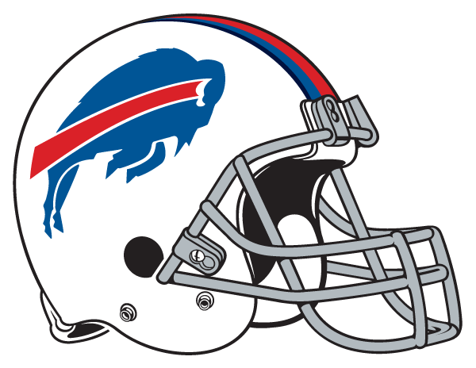

Daily Clips
Friday, August 22, 2014

Buffalo News
Brawling Bills continue their pugnacious play
Marrone harshly chastises team
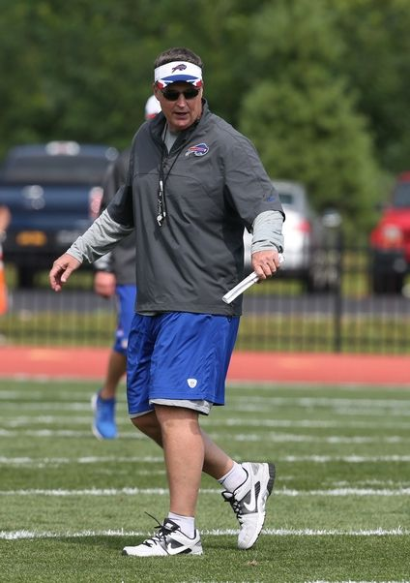
Bills head coach Doug Marrone.
By Jay Skurski | News Sports Reporter | @JaySkurski
on August 21, 2014 - 11:01 PM
PITTSFORD – Doug Marrone is doing his best to adhere to the first rule of Fight Club – that being, don’t talk about Fight Club – but his team is leaving him no choice.
Another scuffle broke out Thursday during the Bills’ final practice of training camp at St. John Fisher College. Early in team work, receiver Marquise Goodwin and cornerback Sam Miller went facemask to facemask after competing for a throw. Marrone then stopped practice after the next play. There didn’t appear to be any punches thrown, but the coach was clearly fed up with something he saw or heard on the field.
“Get your (expletive) right,” he screamed at the team as he ordered them to line up on the sideline to run a sprint.
Defensive end Jerry Hughes said something back to the coach, leading Marrone to direct a string of expletives at him, saying at one point “you don’t have to play on this team.” Hughes’ teammates implored him to step away from the confrontation.
Following practice, Marrone pulled Hughes out of the defensive line’s huddle for a conversation.
“I told Jerry that I love the way he practices and I love the way he plays special teams – how he goes about it,” Marrone said. “We’ve got to get some other guys who are starters to do that, too. That was my conversation with him.”
Marrone denied that he was talking directly to Hughes during his outburst.
“That’s directed to anyone that doesn’t want to be a part of the team,” he said.
At Wednesday’s practice, a full-scale brawl erupted, with center Eric Wood and defensive end Bryan Johnson at the center of it. Wood, who suffered a cut on his nose, yelled “I’ll (expletive) kill you!” at Johnson several times.
Marrone made it clear then his disdain for fighting. So why did it happen again Thursday?
“Lack of respect,” the coach said.
Respect for the game, respect for coaches or respect for other players, Marrone was asked.
“All. Check one, check two and check three,” he said.
Marrone then said he’d “handle it myself, personally,” when asked how he’d go about changing that.
“Guys I’m going to say it again, and I’m not going to answer another question. We’re responsible for the integrity of the game,” he said. Can you figure it out? Figure it out. We’re responsible for the integrity of the game. There is no use for fighting in the game of football. Period. End of discussion. Move on.”
That’s something his team hasn’t been able to do up to this point.
Defensive tackle Kyle Williams – who did not practice Thursday because of a leg injury – spent considerable time talking with Marrone after the blow up.
“I think it was important for him to voice his point of view and his opinion on what was going on, and make sure he got that across to the team, which he did,” Williams said. “And make sure that everybody understood, you know, what’s at stake here.”
Williams, 31, is a team captain and one of the most respected voices in the locker room. He also pulled Hughes aside at one time.
“We just talked about being a pro and making sure we keep it that way all the time,” Williams said.
The Bills opened camp July 20. They’ve had more than 20 padded practices since then. The most common explanation among players is that tensions start to run high in that amount of time.
“We’ve been here awhile. We’ve been hitting each other awhile. That kind of thing spills over from time to time, but at a certain point, you have to be a professional and understand that there are guys here trying to make the team that are out here competing,” Williams said. There are times that you’ve just got to walk away from it.”
What was unusual about Marrone’s outburst Thursday is that it came in a public setting – albeit without fans – in front of media members.
“I mean, he’s a fiery guy. That’s not the first time that he’s been adamant or passionate about anything. He’s like that all the time,” Williams said. “That’s nothing new – it’s just a different subject.”
…
Cornerback Leodis McKelvin sat out practice with a groin injury. Marrone said he hasn’t been cleared by doctors to play in Saturday’s home preseason game against the Tampa Bay Buccaneers, but that could change prior to kickoff.
Tight end Tony Moeaki (hamstring), cornerback Mario Butler (ankle), cornerback Bobby Felder (groin) and safety Jonathan Meeks (neck) also sat out practice Thursday.

Buffalo News
Bills training camp: Weather move
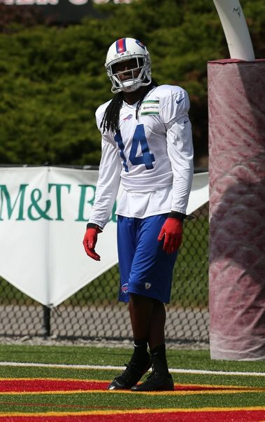
Bills wide receiver Sammy Watkins sat out team drills during Thursday’s practice. James P. McCoy/Buffalo News
Thursday: Day 20 of 20.
Switching it up: The final practice of training camp was moved up from 2 p.m. to 10:30 a.m. because of the threat of inclement weather. The practice was also closed to fans.
Doing more: Wide receiver Sammy Watkins went through “routes versus air,” but did not participate in team drills. Watkins is questionable for Saturday’s preseason game because of a rib injury.
Stepping in: With Kyle Williams out of practice Thursday with a leg injury, Corbin Bryant got first-team reps at defensive tackle.
Schedule: The portion of training camp open to the public (and media) is over. The Bills, though, are still at St. John Fisher College. They will go through a walk-through today, then spend the night before returning Saturday to Orchard Park to face the Tampa Bay Buccaneers in Ralph Wilson Stadium at 4:30 p.m.
– Jay Skurski

Buffalo News
$890 million Pegula bid for Bills is highest of 3 in preliminary round, Forbes reports
By Jerry Zremski | News Washington Bureau Chief | @JerryZremski | Google+
on August 21, 2014 - 9:11 PM
None of the three bidders for the Buffalo Bills offered more than $900 million, Forbes magazine reported Thursday, a day after the magazine pegged the team’s value at $930 million and said that it was unlikely to leave town.
The $890 million bid by Buffalo Sabres owner Terry Pegula and his wife, Kim, was the leader in the nonbinding first round, the magazine reported. A Toronto group fronted by rocker Jon Bon Jovi was second, at $820 million, while Manhattan developer Donald J. Trump offered $809 million.
In naming the bid amounts, Forbes cited two sources familiar with the sale of the Bills who are not yet directly involved in the deal.
After submitting their preliminary bids, the bidders were given access to the Bills’ financial records for use in preparing binding bids, which are due in the next few weeks.
But the lower-than-expected first-round bids may delay the process, meaning that National Football League team owners would not be able to approve a new owner for the Bills at their October meetings, Forbes said.
In his Forbes article, Mike Ozanian wrote that the NFL may not want the bad publicity from a sales price of under $900 million so soon after billionaire Steve Ballmer paid $2 billion for the National Basketball Association’s Los Angeles Clippers.
Describing the process as “the circus that has been masquerading as the sale of the Buffalo Bills,” Ozanian, who reports on the business of sports for Forbes, said: “The best thing NFL Commissioner Roger Goodell could do right now is convince the Wilson trust to fire Morgan Stanley and start over. There is no economic reason why the Bills must be sold during the next few months.”
A spokesman for Morgan Stanley, the New York investment banking firm that is handling the sale of the team, declined to comment.
However, it is common in business transactions for the first round of bids to come in significantly lower than the final bids because no business people want to overpay unless they have to.
In addition, there appears to be a good reason why the family of Bills founder Ralph C. Wilson Jr., who died at 95 on March 25, would want to sell the team in the next few months.
“Estate taxes are due nine months from the date of death,” making them due for Wilson’s estate on Dec. 25, said David H. Alexander, an estate attorney with Gross Shuman Brizdle & Gilfillan in Buffalo.
Nevertheless, Ozanian suggested that the trust that now controls the Bills should hire an investment banker that will not require bidders to sign a restrictive nondisclosure agreement, which has prevented potential bidders from speaking with each other and the league.
The nondisclosure agreement has not prevented a wide range of bid figures from being floated in the media, however.
For example, a Business First report last month said the bid from the Pegulas was $1.3 billion. The New York Post previously reported that the Pegulas’ bid topped $1 billion.
But The Buffalo News later reported that all the figures cited by the media at the end of the first round of bidding in July were inaccurate.
If the Forbes figures are accurate, though, it would mean that all three bidders were trying to get a bargain.
Their bids were far under Forbes’ estimated value for the team of $930 million, which was $65 million, or 7.5 percent, higher than the 2013 estimate.
Of all 32 NFL teams, only the St. Louis Rams – valued at $930 million – ranked lower than the Bills.
Forbes also said the Bills had revenues of $252 million and an operating income of $38 million, far short of the $560 million in revenue and $246 million in operating income enjoyed by the Dallas Cowboys, the league’s most valuable team.
Still, Forbes remains bullish on the Bills’ future in Buffalo.
“Whoever buys the Bills will most certainly keep the team in Buffalo,” the magazine said. “The terms of the 10-year lease the team agreed to with Erie County last year require anyone moving the Bills to pay the county $400 million should the team move before the end of the 2019 season. It also allows the public entities to get a court injunction preventing the Bills from moving.”
Ozanian predicted that the Rams and the Oakland Raiders would eventually move to a new stadium in their former home, Los Angeles, which is currently without an NFL team. Both the Rams and the Raiders have leases that would allow them to move after this season, as do the San Diego Chargers.
Forbes also noted, though, that the Bills’ lease includes a clause that permits the Bills to terminate the deal after the seventh year, 2020, for a relatively small $28.4 million penalty.
The Cowboys once again topped the Forbes list of the league’s most valuable franchises, at $3.2 billion. The New England Patriots ranked second at $2.6 billion, and the Washington Redskins came in third at $2.4 billion.
“There is a widening wealth gap in the NFL due to the piles of cash big market teams generate from modern stadiums and the premium a buyer would be willing to pay for entry into the most elite U.S. sports league in a big city,” Forbes said.
Forbes said that it calculated its estimates based on data and other information from sports bankers, several NFL team executives, financial reports by companies such as Fitch and Moody’s, trade publications, consulting firms and stadium leases.
Meanwhile, the Bills have been showing off their Orchard Park facilities to prospective buyers this week, The News has learned.
The sales process took another step Thursday with at least one tour.
Two sources told The News that Terry and Kim Pegula and one other group checked out Ralph Wilson Stadium, the ADPRO Sports Training Center and the team’s offices Thursday.
Another source said the group fronted by Bon Jovi was scheduled to tour the facilities Wednesday but did not show up for an unknown reason.

Rochester D&C
Doug Marrone's temper erupts during Bills practice
Sal Maiorana, Staff writer 3:15 p.m. EDT August 21, 2014
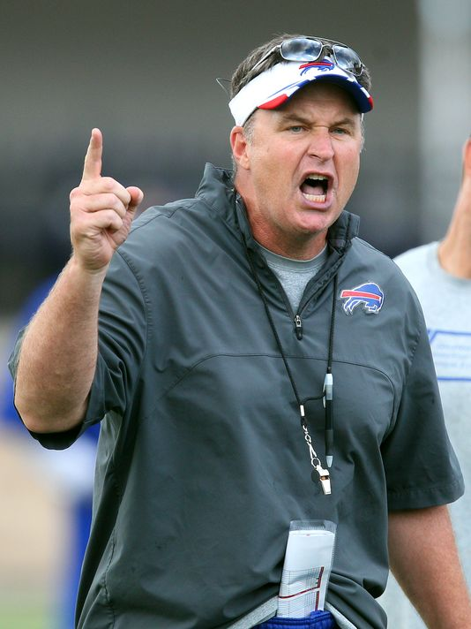
Bills head coach Doug Marrone was not happy with his teams effort in practice and ripped into them and making them do some extra running.(Photo: Jamie Germano/@jgermano1/, STAFF PHOTOGRAPHER)
Although the Bills are staying at St. John Fisher College through Saturday morning, they held their last full practice Thursday morning, and not a moment too soon.
After more than a month of pounding on each other, tempers have gotten short the last few days, and another couple of scuffles broke out during the workout that was pushed back to the morning - and closed to the public - due to a threat of afternoon thunderstorms.

This on the heels of a nasty altercation Wednesday when center Eric Wood and defensive tackle Bryan Johnson exchanged punches during a live goal-line drill.
Thursday, Marrone stopped practice shortly after it had started 11-on-11 team drills and screamed at the team, one of the most vocal and profanity-laced public outbursts anyone in the media has seen from Marrone, who is usually mild-mannered and observant during practice.
Angered by the fighting that has taken place the last few days, Marrone ordered the team to line up and run a sprint, and when defensive end Jerry Hughes seemed to express an attitude, Marrone yelled at him, "You don't have to play on this team."
Marrone was clearly irritated when he met the media later, and didn't want to get into the specifics of what happened, but he said his comment to Hughes wasn't exclusive to him. "No, that's directed to anyone that doesn't want to be a part of the team," he said.
Wednesday: Camp session ends with fight
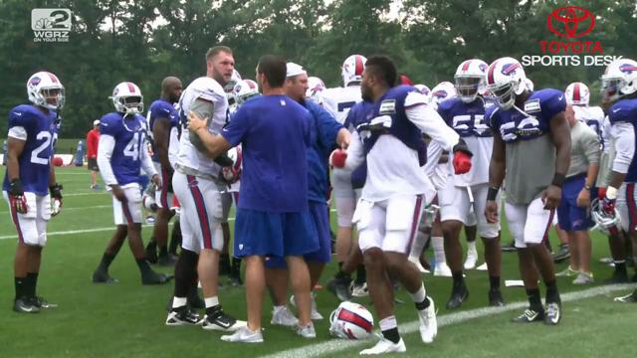
Tempers flared at a Buffalo Bills camp session. Video by WGRZ-TV
After practice, Marrone went over to where the defensive linemen were huddling and he pulled Hughes aside for a chat. When asked about it, Marrone said, "I told Jerry that I love the way he practices and I love the way he plays special teams, how he goes about it," Marrone said. "We've got to get some other guys who are starters to do that, too. That was my conversation with him."
Pressed on the fighting issue and why he lost his cool, Marrone said his stance on fighting is that it disrespects the game, the coaches, and the players.
"It's not part of the game," he said. "Therefore, I don't want to speak about it. It hurts the integrity of our game the more we talk about it. That's how I feel about fighting. We're responsible for the integrity of the game. Can you figure it out? Figure it out. We're responsible for the integrity of the game. There is no use for fighting in the game of football. Period. End of discussion. Move on."
Hughes declined to comment as he walked off the field.

Rochester D&C
5 things Sal learned about Bills in training camp
10:24 p.m. EDT August 21, 2014
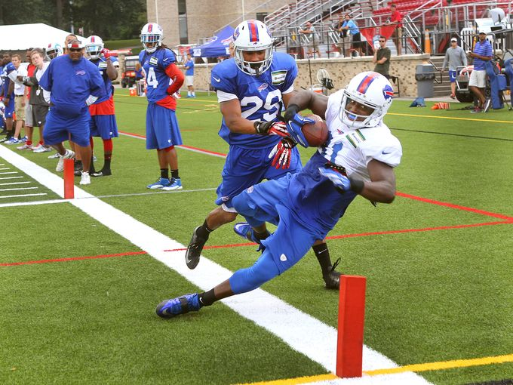
Bills receiver Marcus Easley (81) keeps his feet inbounds after catching a pass in corner of the end zone over Ross Cockrell (29). (Photo: Jamie Germano/@jgermano1/ STAFF PHOTOGRAPHER)
As the Bills wrap up the training camp portion of their regular-season preparation at St. John Fisher College, coach Doug Marrone reiterated Thursday one of the first things he said when the team arrived in Rochester back on July 20.
"For us as coaches, there's always a sense of urgency (to win)," Marrone said following the Bills' last full practice at Fisher. They still have closed-to-the-public walk-throughs on Friday and Saturday.
"The days of three-year plan, five-year plan, you've got to be kidding me," he continued. "That doesn't happen. The sense of urgency for coaches is extremely high no matter what the situation is. We're close. Now, what's it going to take to get over the top? It's a matter of either you get over the top or you don't, and we've got to find a way to get over the top. I'm doing everything I possibly can."
His situation is a bit different than most, though, because the team is about to move forward with a new owner, and if a 15th straight non-playoff season occurs, Marrone and his staff might not survive the transition.
It's too early to know how this season is going to play out, but this Buffalo team has more depth than it has had in recent years, and if quarterback EJ Manuel proves he truly is a first-round talent, and the team doesn't suffer too many injuries, the playoffs may be in reach.
Here are five things that I learned watching the Bills almost every day for the past month:
1. The quarterback depth chart may be the worst in the NFL this side of Cleveland. This is something I've been harping on all offseason, and after watching Manuel, Jeff Tuel, and Thad Lewis in training camp, I feel stronger than ever that the Bills blundered in not signing a competent NFL veteran to be Manuel's backup/mentor.
The sense of urgency for coaches is extremely high no matter what the situation is.
Coach Doug Marrone
The faith Marrone and GM Doug Whaley showed in Tuel and Lewis seems like an egregious error because if Manuel gets hurt, it's hard to fathom that either could keep the Bills offense afloat. The first round of cuts comes Tuesday, and it would not surprise me that in the next week to 10 days, the Bills cut Lewis (who has been the worst of the group) and bring someone in. At this point, almost anyone available would be an upgrade.
2. Sammy Watkins is a whole lot of fun to watch. Before the rookie wide receiver hurt his ribs in the Steelers game and had to sit out the last few practices here, Watkins was all that he was advertised to be. The No. 4 overall pick seemed to make a highlight reel catch every other day, and he flashed some of the brilliance that prompted the Bills to pull off the bold draft day trade to move up and take him.
The next step for Watkins will be to show something in the games, because he really hasn't done that in the brief playing time he's seen. And beyond that, he will have to prove that he can play through some pain — rib injuries can be tricky — and show that he's capable of taking the pounding that receivers take. If he does, he could be a special player because the hands, the route running, and the speed are all clearly evident.

3. The offensive line is still a jumbled mess. At times you half expected the Bills offensive linemen to introduce themselves to the player next to them, so frequent were the combination changes and position switches.
With the exception of center Eric Wood, the Bills had every other player rotating in to different spots on the line with a clear goal in mind: To find the best five players, regardless of position. Marrone said continuity is overrated, and that it's more important to identify the right guys who need to be on the field. If they have to do so at a position they haven't always played, so be it. At the very least, the Bills will have a group of well-rounded linemen, which should come in handy when the inevitable injuries strike.
4. The defensive line could be dominant. You can make an argument that the offensive line looked somewhat inept in practice, not because of all the position switching, but because the defensive line is simply that good. There are three Pro Bowlers in Mario Williams, Marcell Dareus and Kyle Williams, plus Jerry Hughes, who had 10.5 sacks last year and looks even faster off the edge this year.
Mix in quality reserves such as Manny Lawson, Stefan Charles, Corbin Bryant, plus surprising late roster addition Landon Cohen (who seems poised to take Alan Branch's roster spot), and defensive coordinator Jim Schwartz can mix and match and keep his guys fresh all day. This group should be significantly better against the run with the help of run-stuffing middle linebacker Brandon Spikes, and it should be able to generate similar-type pass rush to last year when the Bills set a team record with 57 sacks because Schwartz teaches an aggressive, penetration style approach to quarterback pressure.
5. There are going to be some difficult cuts at several positions. This, of course, is a good sign for the Bills because it shows they are beginning to build some depth.
Let's start at wide receiver. Watkins, Mike Williams, Robert Woods, Marquise Goodwin and Chris Hogan (imagine that?) appear to be locks. Not so for Marcus Easley and T.J. Graham who are probably battling for the last spot, and it will come down to their work on special teams. At this point, Easley has the edge.
On the offensive line, Wood, Cordy Glenn, Chris Williams, Seantrel Henderson, Cyrus Kouandjio (only because he was a second-round draft pick) and Cyril Richardson seem set. If the Bills keep eight, that leaves veteran returning starters Erik Pears, Kraig Urbik, and Doug Legursky battling with Chris Hairston, J.J. Unga, and Antoine McClain to make the team.
At tight end, Tony Moeaki may have cost himself a roster spot because he can't stay healthy, though Chris Gragg hasn't exactly done much to warrant the position.
On the defensive line, Branch appears to have played himself off the team after skipping all of the voluntary offseason workouts, and then coming to camp out of shape. He's been running with the third-string almost the whole time at Fisher.
And in the secondary, capable players such as Kenny Ladler, Bobby Felder, and Mario Butler are likely headed to the practice squad

Toronto Sun
Bon Jovi, Toronto group's Bills bid on 'life support'
By John Kryk, QMI Agency
First posted: Thursday, August 21, 2014 04:14 PM EDT
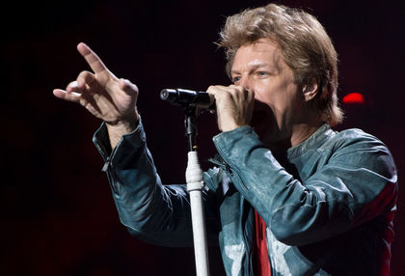
Rocker Bon Jovi is leading a group that hopes to buy the Buffalo Bills. (QMI Agency)
Jon Bon Jovi and his Toronto backers are reassessing whether even to continue in their pursuit of the Buffalo Bills, QMI Agency has learned.
Their bid has been on the rocks for weeks and no one within the group is optimistic they'll wind up buying the NFL team, according to two sources in the position to know.
The group cancelled a scheduled tour of Ralph Wilson Stadium on Wednesday.
"They're hanging on by the skin of their teeth," one source said. "The bid's on life support."
It has nothing to do with the announced departure Thursday of CEO Tim Leiweke from Maple Leaf Sports & Entertainment, whose role in the bid has been overstated (most often by Leiweke himself).
But it has everything to do with (1) the group's limited bidding power with Bon Jovi in the lead, and (2) lingering doubts about whether the trust would sell the club to a group that continues to refuse to commit to keeping the Bills in Western New York long-term.
A source said the Toronto group bowed out of a planned tour of the Bills' stadium in Orchard Park on Wednesday, and has no plans to reschedule it. The tour is a scheduled part of the due diligence process for all finalists, in what Morgan Stanley -- the investment bank conducting the sale for the trust of founding Bills owner late Ralph Wilson -- calls the "final phase."
There are three other known finalists: multi-billionaires Terry Pegula, Donald Trump and Tom Golisano.
The Toronto bid group comprises rocker Bon Jovi (as prospective controlling owner, with about a 30% stake) and his Toronto background investors, each with about 35% shares: MLSE chairman Larry Tanenbaum and Edward Rogers and his family, whose trust runs the Rogers Communications empire.
Sources say the trio are taking the next week or so to assess where their bid is at and to discuss what they could possibly do at this stage to mount a formidable, effective bid.
Morgan Stanley tried to help in that regard, sources said Monday, in suggesting last week that Bon Jovi approach Bills legend and Hall of Fame quarterback Jim Kelly about joining forces. Kelly and his investment partner, Jeffrey Gundlach, hope to latch on as minority investors with another bid.
Kelly and Bon Jovi met, but Kelly rebuffed the rocker's request over concerns his group would eventually relocate the team to Toronto, Tim Graham of the Buffalo News reported Sunday.
As constituted, the Toronto group is limited financially by the amount of cash the rocker can pull together to meet the 30% controlling-owner threshold that the NFL demands.
The group's maximum bid -- which sources say is somewhere between $1 billion and $1.2 billion -- isn't nearly enough to compete with Pegula, the cash-flush multi-billionaire who owns the NHL's Buffalo Sabres. And Bon Jovi, Tanenbaum and Rogers know it.
Remember, the Toronto group's bid already died once after submitting an uncompetitively low first bid July 29. Even after being allowed to resubmit a higher opening, non-binding bid, and being asked to more clearly express a non-relocation intention, it wasn't until the Aug. 9-10 weekend that Morgan Stanley allowed the group to enter the sale's final phase.
A week ago Tuesday, the group had its first face-to-face meeting in Manhattan with sale principals: members of the trust, senior executives of the Bills, Morgan Stanley and the trust's legal adviser Proskauer Rose. It was a desultory meeting that further lowered the Toronto trio's hopes.
As QMI reported Monday, do not interpret Morgan Stanley's match-making attempt with Kelly as any expression of favouritism toward the Bon Jovi/Toronto bid.
The banker merely had this hope: to assuage Buffalonians' concerns about the Toronto group's suspected relocation intentions by teaming it with Mr. Bills-Can't-Move himself, so as to convince other bidders -- especially Pegula -- that the beleaguered group is indeed a viable threat to win the bidding.
Right now it is not.
One source said that, barring a significant development or reformation of the group, the Toronto trio is more likely to disband than submit a binding, definitive bid early next month along with the other finalists.
LEIWEKE'S ROLE MINIMAL
Tim Leiweke might be good friends with Jon Bon Jovi.
And he arranged the partnership between the rocker and Larry Tanenbaum long before founding Buffalo Bills owner Ralph Wilson died on March 25.
Otherwise, multiple sources insist the outgoing CEO of Maple Leaf Sports & Entertainment had a minimal role in Bon Jovi's group bidding on the NFL team.
One source in the position to know even said Leiweke had "absolutely nothing" to do with the Toronto bid.
"Nobody who mattered listened to him," the source said.
Another source, however, said that both Bon Jovi and Tanenbaum -- the MLSE chairman and one of Leiweke's bosses -- probably consulted with the 57-year-old executive at various times. But Leiweke did not have an impactful role within the group, that source said.
What's more, Leiweke's boastful claims of possessing close, helpful friendships with influential NFL power brokers did not materialize, sources said.
Word buzzing around the city since the day he arrived in Toronto in April 2013 is that Leiweke was not shy to boast that his foremost legacy at MLSE would be in bringing the NFL to Toronto.

Forbes
Three Bids For Buffalo Bills Are Each Below $900 Million
The circus that has been masquerading as the sale of the Buffalo Bills has received three non-binding bids to date, each below $900 million, according to two sources familiar with the sale of the National Football League team. Both of these sources are not directly involved in the sale as of yet.
Here are the current offers for the football team, being run by Morgan Stanley MS +1.51% for the trust of the late Ralph Wilson.
Terry Pegula: $890 million.
Toronto Group (Larry Tanenbaum, Bon Jovi, Ed Rogers): $820 million.
Donald Trump: $809 million. (Note, I previously wrote that sources had pegged Trump’s bid in the mid-800s.)
What now? Binding bids for the Bills were originally expected to be submitted within the next few weeks so the NFL ‘s owners could vote on approving the winning bidder in October. But that may not happen given the low bids for a team that I calculate is worth $935 million. Not to mention the bad publicity a sale under $900 million could generate for the NFL so soon after Steve Ballmer bought the NBA’s Los Angeles Clippers for $2 billion.
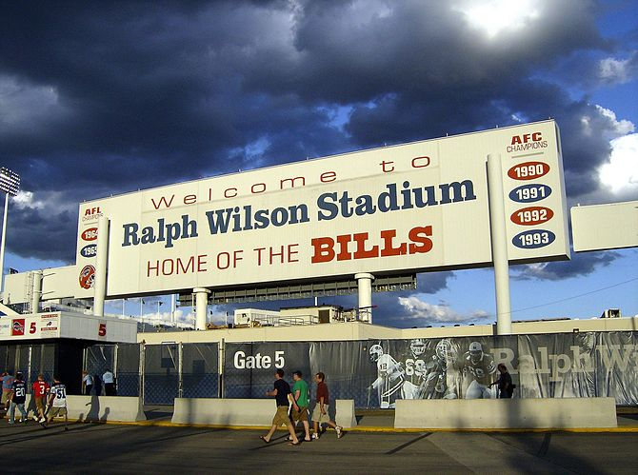
Ralph Wilson signage display past glories (Photo credit: Wikipedia)
The best thing NFL commissioner Roger Goodell could do right now is convince the Wilson trust to fire Morgan Stanley and start over. There is no economic reason why the Bills must be sold during the few months. Let the Wilson trust hire a banker that will not require potential bidders to sign an ultra-restrictive non disclosure agreements, so that people interested in buying the team could speak with each other and the NFL.
But the Wilson trust and NFL need to move quickly if they want to restore interest in the team. Rumors have surfaced that Tim Leweike is leaving Maple Leaf Sports & Entertainment. The CEO of MLS&E has denied he is departing the company any time soon.
But if Leweike is indeed thinking of moving on, then I take it as a sign that Tanenbaum, the chairman and minority owner of MLS&E who hired Leweike in part to help him buy an NFL team, is losing interest in the Bills. That would all but guarantee the team is sold for less than $900 million unless Rogers were to up the ante without Tanenbaum.

AP
Marrone upset by Bills lack of practice discipline
By JOHN WAWROW
— Aug. 21, 2014 4:45 PM EDT
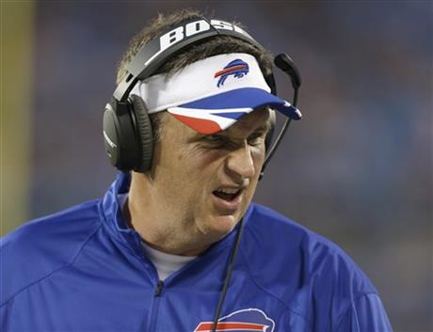

Buffalo Bills head coach Doug Marrone watches the action during the first half of a preseason NFL football game against the Carolina Panthers in Charlotte, N.C., Friday, Aug. 8, 2014. (AP Photo/Bob Leverone)
By: JOHN WAWROW (AP)
PITTSFORD, N.Y. (AP) — Bills coach Doug Marrone blew up at his players on Thursday, sending a message that he's fed up with too many fights and post-whistle shoving matches during practice.
Marrone cleared the field during the middle of a team drill and ordered players to run sprints after several of them exchanged shoves. That included receiver Marquise Goodwin pushing down rookie cornerback Sam Miller from behind.
Marrone then directed his anger at starting defensive end Jerry Hughes on the sideline.
Looking directly at Hughes, Marrone used several profanities in telling the player to stop complaining.
"Why can't you handle it as players?" Marrone yelled. He then motioned toward the locker room and said: "Do you want to play on this team?"
Once again looking at Hughes, Marrone said: "If you've got a problem with me, you need to come and tell me."
Marrone spent a few minutes meeting with Hughes following practice.
Walking off the field, Hughes referred questions about what happened to Marrone, and added: "the head coach took care of it."
Afterward, Marrone said his comments were directed at the team and not Hughes.
"That's directed at anyone who doesn't want to be part of the team," Marrone said. "I told Jerry that I love the way he practices and I love the way he plays special teams and how he goes about it. And we've got to get some other guys who are starters to do that."
Marrone's blowup occurred on the final day of practice at the Bills' training camp facility in suburban Rochester. The Bills will have two more walk-throughs at camp — both closed to the public and media — before traveling to Orchard Park on Saturday for their preseason game against Tampa Bay.
Several fights have broken out during camp, which opened July 20.
The most intense fight occurred Wednesday when rookie defensive end Bryan Johnson ripped off the helmet of center Eric Wood and then connected with several punches.
Numerous veterans stepped in to defend Wood, who sustained a cut on his nose. Johnson was wrestled to the ground by guard Erik Pears and tight end Scott Chandler.
Hughes wasn't involved in the fight, but yelled a few things from the sideline, including: "Twenty-one days in pads and counting. I love it!"
Marrone, a former NFL offensive lineman, said there's no place in the game for fighting, that it shows a lack of respect for players, coaches and the game.
"Figure it out. We're responsible for the integrity of the game," Marrone said. "There is no use for fighting in the game of football. Period. End of discussion."
Veteran defensive tackle Kyle Williams spent time counseling Hughes immediately following Marrone's blowup.
"We talked about being a pro and making sure we keep it that way all the time," said Williams, a nine-year veteran and longtime defensive captain.
"We've been hitting on each other for a while and that kind of thing spills over from time to time," Williams said. "But at a certain point, you have to be a professional and understand there's guys here trying to make the team. And there's a time that you've just got to walk away from it."
Running back Fred Jackson, another team captain, welcomed Marrone's outburst.
"I think guys got it loud and clear today," Jackson said. "We weren't getting anything accomplished in the beginning of it. So he had us go to the sideline, get it all out of our system and move on."
NOTES: Marrone said WR Sammy Watkins (bruised ribs) and CB Leodis McKelvin (groin) have not been cleared to play against Tampa Bay on Saturday. Watkins has been limited in practice this week since being hurt in a 19-16 loss at Pittsburgh last weekend. McKelvin has missed the past two practices. ... Marrone won't say how long he expects to keep his starters in on Saturday. But he hasn't ruled out playing his starting offensive line in Buffalo's preseason finale against Detroit next week.

BuffaloBills.com
4 takeaways from the final Bills camp practice
Posted 14 hours ago
Chris Brown Bills InsiderEmail @ChrisBrownBills Blog: Inside the Bills
The Bills put a wrap on their 2014 training camp Thursday with their final full scale practice session.
Here are the four takeaways from Buffalo’s final practice at St. John Fisher.
Offense made strides
During the first week of training camp Buffalo’s offense looked out of sync and had trouble stringing positive plays together during 7-on-7 and 11-on-11 during practice sessions. Each week however, their performance improved and with it came more consistent play. It appeared to hit critical mass during the two days of practices in Pittsburgh and finished on a high note this week.
Fred Jackson feels the entire unit has been in lockstep of late.
“I think getting everybody on the same page,” Jackson said. “That’s the thing about offense. You can’t have one guy go out and make a play. You can have one guy contribute, but if we’re not all on the same page we’re going to look like it.
“The best thing we can do is all get on the same page so we’re where we’re supposed to be, make plays how we’re supposed to make them. Having EJ get comfortable with the way receivers run routes where they’re going to be. Where we fit in pass protections and that’s how we’re evolving and hopefully when we get to the regular season we’ll be able to hit the ground running.”
As EJ Manuel sees it on field communication has improved by leaps and bounds and that has translated into better execution.
“Communication has been huge,” said Manuel. “That’s one of the things I really wanted us to work on from OTAs moving into training camp. I feel like our communication has been tremendous from what it was the first day we got out here until now. Especially on the field telling guys this is what I was expecting on this route, or this is why I ran the route this way or this is what I saw in that protection. That kind of communication has improved a lot.”
What can Brown do for defense?
He played all three linebacker positions in his time with the Cardinals at Louisville. That experience might prove to come in handy for rookie LB Preston Brown. Earlier in the week he was what head coach Doug Marrone likes to call cross training as the Bills coaching staff tries to find a suitable replacement for Nigel Bradham in the opener knowing he’ll be serving a one-game league-imposed suspension.
Brown has been lining up at the outside linebacker positions in addition to his middle linebacker role. Ty Powell and rookie Randell Johnson have also been in the mix as an outside linebacker replacement for Bradham in Week 1 at Chicago.
On Thursday Brown was lining up in just about every defensive package during team portions of practice. He’s seen a ton of work in nickel packages and was also getting first team reps at middle linebacker.
“It’s good to be busy,” Brown said. “The more things I can do to help the team I’m just trying to do that. Going out as SAM, WILL, mike, whatever it is I’m willing to do it.”
Brown is really pushing veteran Brandon Spikes for time on the field at middle linebacker, something he set out to do from the start. He’s not going to be presumptuous, but Brown admits it’s hard not to think about the possibility of being a starter as a rookie.
“It’s always in the back of your mind. You know that somebody is going to have to be out there playing,” he said. “So you’re always thinking about it, but you’re just trying to get better every day. In those games you just try to make strides. After these next couple of weeks we’ll be in the real fire, so we’ve got to be ready for the real games.”
Brown, who has already earned high praise from his defensive coordinator Jim Schwartz, got some more from his head coach on Wednesday when Doug Marrone appeared on Bills flagship station WGR Sportsradio 550.
“Preston Brown is having as good a camp as Kiko (Alonso) had last year,” said Marrone.
His best play Thursday was his tight downfield coverage on Scott Chandler to foil a touchdown pass attempt from EJ Manuel.
Two minute drill
In preparation for Saturday’s game the Bills ran a pair of two-minute drives in practice Thursday. After a pair of short to mid-range completions, EJ Manuel hit Mike Williams down the right sideline with a 15-yard pass to the defense’s 41-yard line with 51 seconds left.
Manuel then hit Scott Chandler down the seam for a first down, and followed that with a completion to Fred Jackson out of the backfield for another first down. The offense then called timeout with 28 seconds left. After a short gain play and pair of incomplete passes to Williams and then to Chandler in the end zone, it was 4th-and-5 at the defense’s 20 for the offense with 19 seconds remaining.
Manuel threw low and outside to Mike Williams to keep the defender from making a play on the ball along the right sideline, but the ball was trapped off the turf and an incompletion.
The second unit tried to put together a drive as well with Thad Lewis running things. Lewis had an incomplete pass sandwiched by a completion to Chris Gragg and another to Caleb Holley. Absent first down yardage, it was fourth down. Lewis tried to find a target over the middle, but the ball was picked off by Corey Graham ending the drive.
Big Mike
With Sammy Watkins not participating in the team portions of practice Robert Woods has largely been the outside receiver opposite Mike Williams with the top offensive unit. EJ Manuel was looking for him early and often in practice Thursday.
Williams had five catches before they were midway through practice. It’s been a stellar camp for the receiver they acquired via trade and his teammates and coaches are noticing.
“I think Mike has done a great job getting himself healthy and doing a great job of competing,” said receivers coach Rob Moore. “I’ve been really pleased with what I’ve seen so far.”
“Mike has definitely proven to me that he can go out and make big catches for us,” said EJ Manuel. “In OTAs we weren’t necessarily always on the same page. But the things we’ve been doing after practice and trusting him in practice and letting him go up and make big catches for me has been huge for us. I’m very excited to have both of those guys in our receiving corps this year.”

BuffaloBills.com
2014 Training Camp Awards
Posted 12 hours ago
Chris Brown Bills InsiderEmail @ChrisBrownBills Blog: Inside the Bills
It’s time again to award the Bills players who performed the best through what was one of the longest training camps in recent memory.
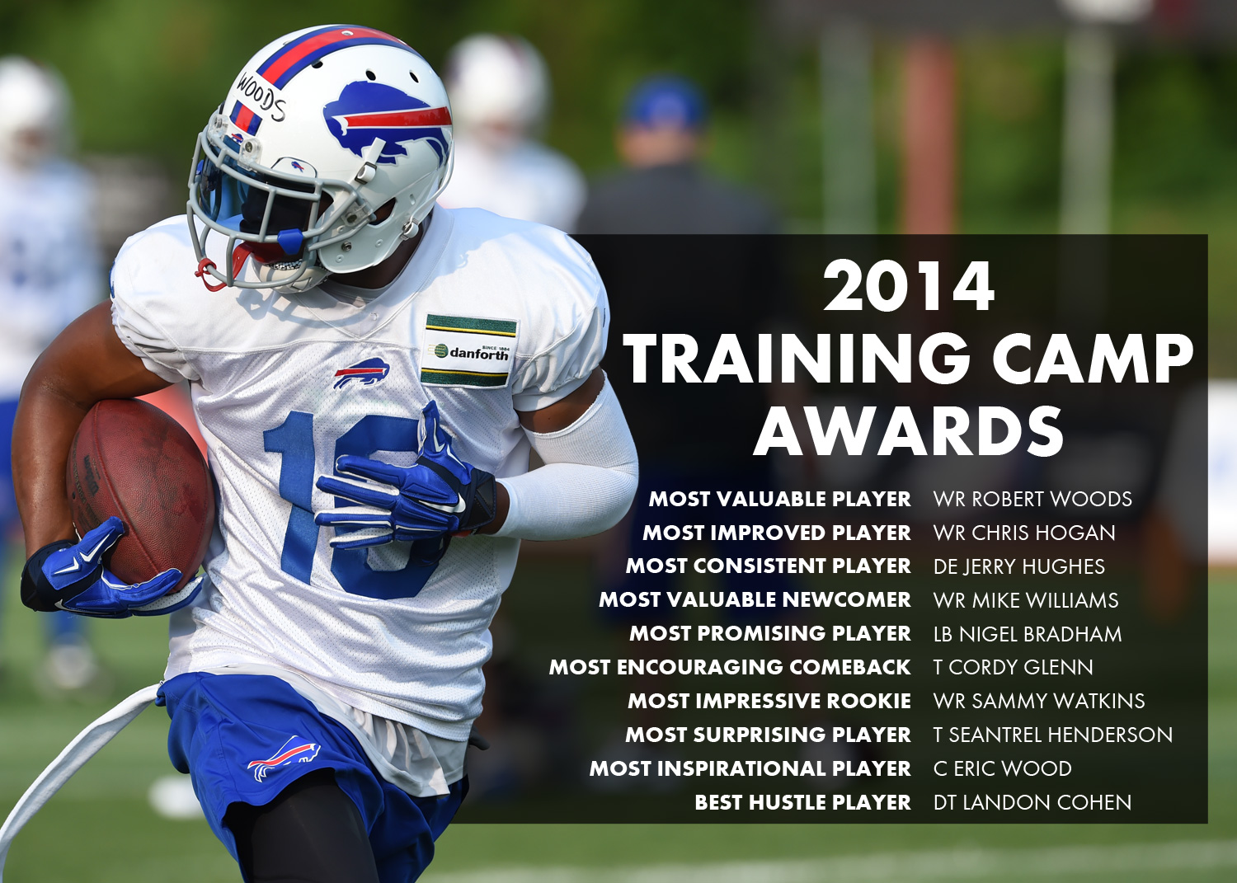
Bills Training Camp Awards
The team and coaching staff still have about two weeks of work left before the season opens, but here now are our ninth annual Training Camp Awards for those who excelled at St. John Fisher.
Most Valuable Player
His training camp didn’t get off to a fast start, but once he was on track, WR Robert Woods was difficult to stop. He’s produced in every preseason game. Say what you will about him not getting the starting nod in August, but he’s far and away the team’s leading receiver this preseason. The second-year wideout is going to play a lot this year and deliver solid production. He might be the most versatile receiver on the roster.
Most Improved Player
The guy who scraped and clawed to get on the roster last year improved his game in every facet. With burst off the line, route running, hands, strength and speed, WR Chris Hogan was able to make upgrades across the board. All those improvements showed in his play, which is why he’s in contention for the top slot role.
(Honorable mention – QB Jeff Tuel)
Most Consistent Player
From the very beginning of training camp, DE Jerry Hughes was a player who was hard not to notice. Whether the practice segment was 7-on-7, one-on-one pass rush or 11-on-11 Hughes was constantly screaming in off the edge and wreaking havoc in the offensive backfield. There were a few practices where he had three sacks in a session during team segments. The pass rusher looks ready to dominate this season.
Most Valuable Newcomer
The Bills made a lot of quality additions to the roster this offseason, but the acquisition of WR Mike Williams has looked the best to this point. Williams is an expert at high pointing the ball, which serves this team two-fold. It makes him a scoring threat every time the team is in the red zone. Perhaps more importantly he’s infused confidence in EJ Manuel to be more aggressive knowing he’ll win most jump ball battles. (Honorable mention – CB Corey Graham)
Most Promising Player
The difference between LB Nigel Bradham’s play last year at this time to now is remarkable. His commitment to the game has allowed him to match his physical talent with his mental acuity. Putting those two things together has turned Bradham into a player that is always in position to execute. (Honorable mention – RB C.J. Spiller)
Most Encouraging Comeback
Just about everybody on offense was waiting on left tackle Cordy Glenn to return. No one was necessarily worried, but seeing him cleared fully this week undoubtedly let a lot of other offensive teammates breathe easier.
Most Impressive Rookie
WR Sammy Watkins started training camp with a bang and showed rare ability at a position where there’s an awful lot of talent in the league. Watkins workmanlike approach to the game will only serve to make him a special player. (Honorable mention – LB Preston Brown)
Most Surprising Player
We’ve heard the stories about physically gifted players who never pan out. But T Seantrel Henderson came into the spring practices with his head on straight and looks determined to make good on the opportunity the Bills afforded him. Henderson has the physical tools to dominate at offensive tackle, which is why he’s in line to land the starting right tackle job.
Most Inspirational Player
He leads by example, doesn’t mind doing the dirty work and never allows the defense to think they got the best of the offense. It’s evident to everyone on the offensive side of the ball that C Eric Wood is a player to be respected and followed. (Honorable mention – RB Fred Jackson)
Best Hustle Player
DT Landon Cohen arrived at camp after signing as a late addition. He certainly made up for lost time with a solid preseason as he has a legitimate shot to make the roster. Cohen has skills, but it’s his non-stop motor in practice and games that puts him in position to make plays.

BuffaloBills.com
10 big changes unveiled at Ralph Wilson Stadium
Posted 5 hours ago
Anna Stolzenburg CorrespondentBills on Facebook Bills on Twitter
With the first major unveiling of the Ralph Wilson Stadium renovations set for the preseason home opener on August 23, take a sneak peak at the changes you'll notice on gameday.
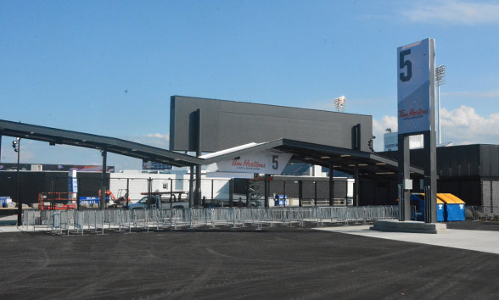
1)A new front door
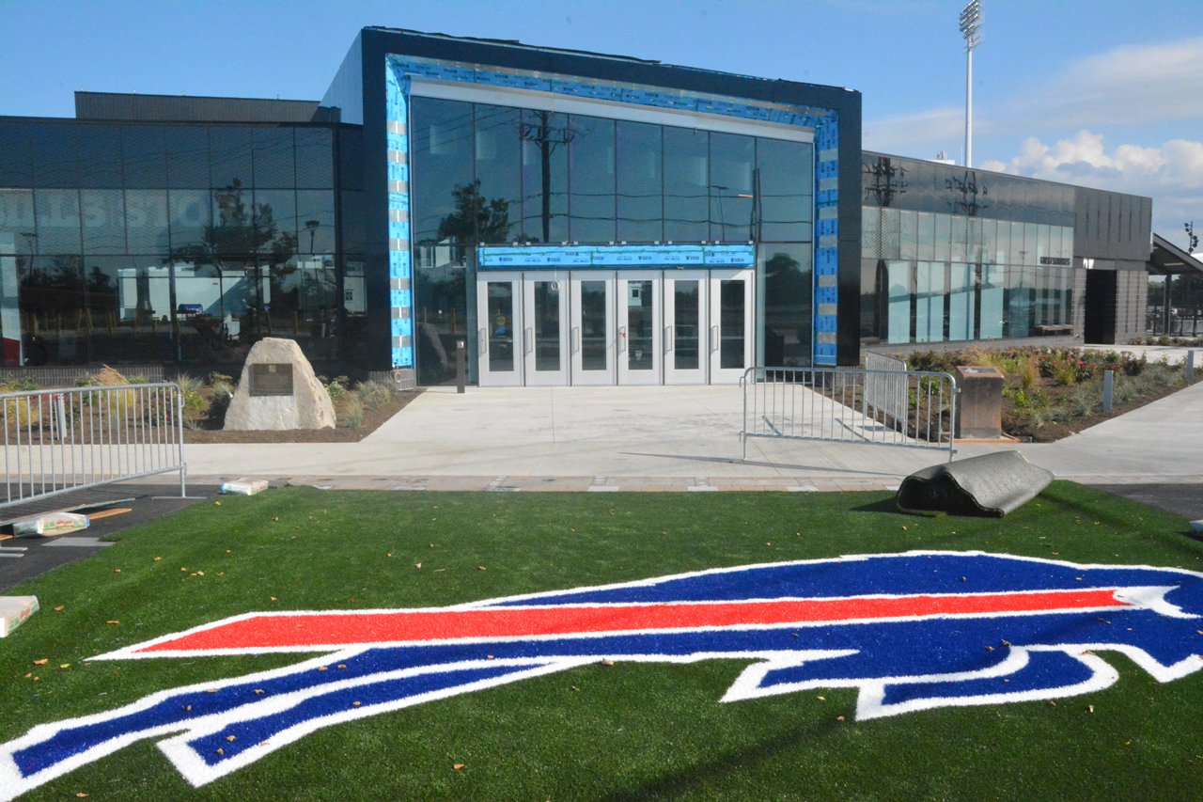
View Gallery | 38 Photos
Ralph Wilson Stadium renovations unveiled
If you’re big on first impressions, the new Ralph Wilson Stadium welcome won’t disappoint. At four times the size of the old Bills Store, the formidable new store sits conveniently on Abbott Road, greeting fans not only as they head into the stadium on Sundays but on every other day between.
2)Bills gear heaven
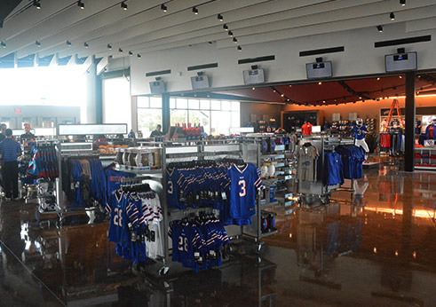
As any good host would, the Bills Store will not just welcome you warmly to the home of the Bills, it will send you away with a parting gift. Inside its modern glass façade and past the larger-than-life wall graphic of QB EJ Manuel lies gear, gear, and more gear. Among the Bills Alex and Ani Bracelets and abundant Nike apparel is even a trio of New Era Bills camps EXCLUSIVE to the Bills Store at Ralph Wilson Stadium. Ask to see under the cap. You won’t be disappointed.
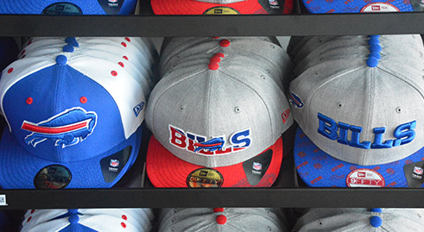
Oh, and by the way, the store has extended its hours dramatically, giving you more time to stop and shop: Monday through Saturday: 10 a.m to 9 p.m., non-gameday Sundays: 12 p.m to 5 p.m., gamedays: 9 a.m. until 1 hour after the end of the game.
3)Improved entry
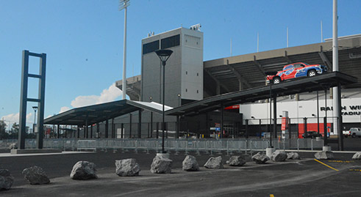
They’re called Super Gates for a reason. Just look at them! The number of gates deopped from eight to six with the renovations, but the new Super Gates are more efficient and positioned around Ralph Wilson Stadium based on years of study of the flow of fans on gamedays.
4)Easier navigation
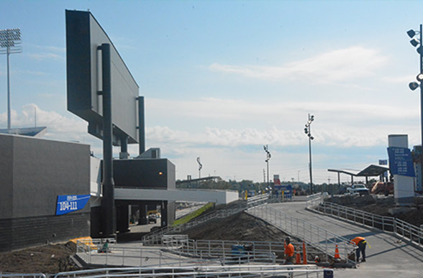
Ditch the map and compass; you’ll no longer have a hard time finding your way around the stadium to your seat. The perimeter of the stadium has been pushed out to accommodate better and more pathways, accompanied by new, easy to read signage.
Fun fact: It took 11.1 acres of asphalt to finish the project, parking lots included.
5)Light!
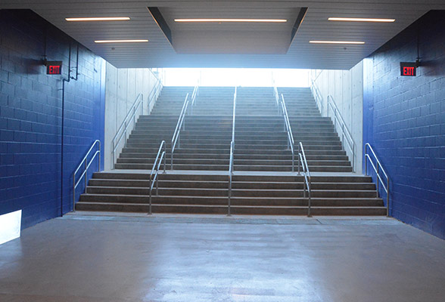
The dimly lit 100-level concourses are no more. At a number of points throughout the level – including at the monumental stairways that replaced the old sets of switchback stairs – natural light comes through, brightening the main channel of Ralph Wilson Stadium.
6)A new bar scene
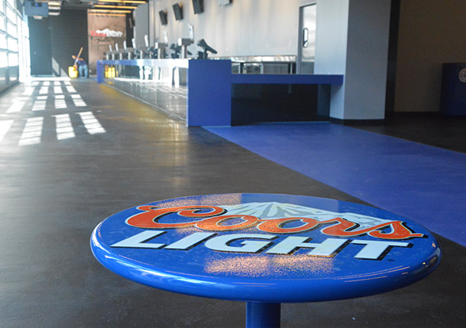
The Coors Light Sports Bar is just flat out cool. Where the old front office administration lobby used to be, now sits a huge Sports Bar with plenty of taps, food, and places to eat and hang.
7)Concessions aplenty
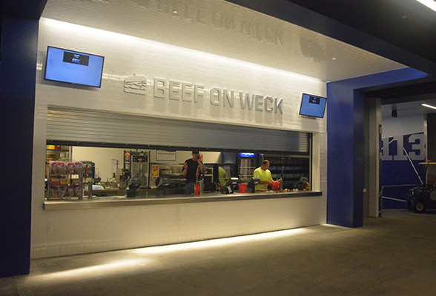
LaNova, Duff’s, Tim Hortons, Pizza Logs, and a slew of new choices in concessions make your gameday a whole lot tastier. With a number of WNY-based options it doesn't really get more "Buffalo" than this.
8)More screens
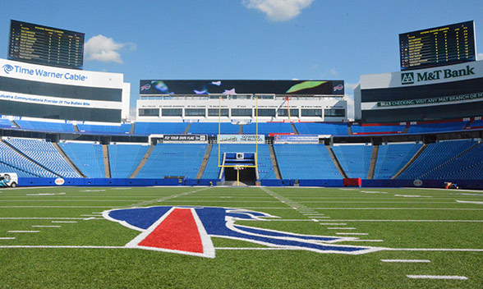
Two new video boards were constructed using the screens from the existing video board at the stadium and placed on either indoor club on the East End of the Ralph. One will show scores and stats from around the league - both NFL and fantasy - and they other will mirror the bigger boards. Those two boards bridge a third new board to be used for advertising.
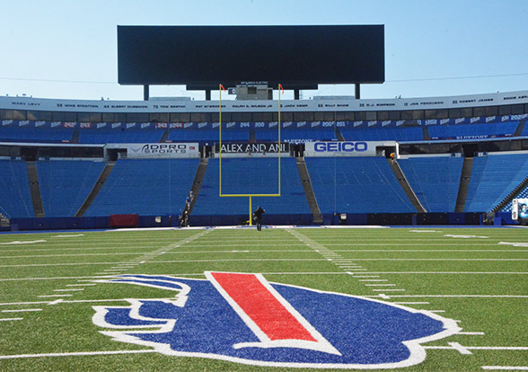
On the opposite end of the field, the existing frame was used to hold a new screen, wider by 60 feet and packing a visual punch.
9)A new home for the Tim Russert Plaza
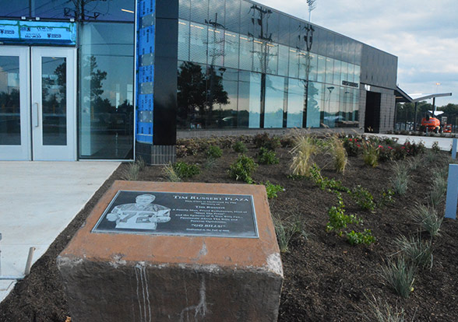
The commemorative Tim Russert Plaza plaque has been relocated to a prominent location outside of the Bills Store, and the many stones purchased by Bills fans from all over the world in commemoration and celebration have been relocated on the pathway that stretches the front of the store.
10)A Buffalo Bills gameday to be proud of
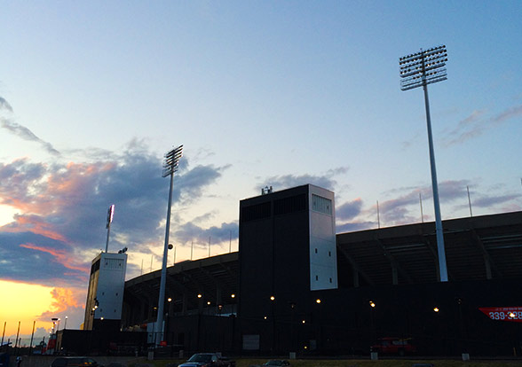
The $130 million renovations were designed for the fans, and when the nearly completed stadium is unveiled at the preseason home opener on August 23, then again after the renovations are completely finished for the regular season home opener September 14, Bills fans will have a revolutionized gameday experience and a stadium to be proud of.

